General Information

The Purchasing Card is a VISA Card issued by PNC Bank. The College is required to pay the full amount of the bill every month for all charges made.

The purpose of the Purchasing Card Program is to establish a more efficient, cost-effective way for departments to make purchases of less than $1,000. The Purchasing Card is for business purposes only and may not be used for personal purchases. The Purchasing Card may only be used by the authorized user on record at PNC Bank. Card security should be treated with the same level of care as a personal credit card.

You are being entrusted with the ability to make small-dollar purchases on behalf of the College. If authorized, you will also be trusted to pay travel and entertainment expenses with your card.  Along with this trust comes responsibility.

Allocators are responsible for allocating and submitting the receipts and statements for the Department. These tasks have due dates and are required to be submitted by the due dates. It is crucial receipts are turned in promptly. Not doing so, can result in card suspension and/or termination.

Cardholders are expected to make sound business decisions in the best interest of the College, and always comply with the policies and procedures as set forth in this User Guide.

Contacts & Phone Numbers

Purchasing Office Purchasing Office Accounts Payable PNC Bank Customer Service

Tiffany Wells Melissa Gruber Brenda Landvater (800) 685-4039

X1575 x1186 x1214

[wellst@etown.edu](mailto:wellst@etown.edu) [gruberm@etown.edu](mailto:gruberm@etown.edu) [landvabj@etown.edu](mailto:landvabj@etown.edu)

**Benefits of the purchasing card program**

Using the Purchasing Card will be a benefit to the College, its suppliers, and your department. The College will save time and money by consolidating paperwork, suppliers will receive payments more quickly, and your Department will get its supplies without unnecessary delays.

CardholdersWill be able to obtain goods and services directly from vendors without using a purchase order. This streamlines the purchasing process and helps improve turnaround time on orders. When used for travel, automatic travel accident insurance and lost luggage insurance are included. It also significantly reduces the workload and costs, related to the purchase and payment process and contributes to high customer satisfaction.

Elizabethtown CollegeThe Purchasing Card program provides a cost-efficient, alternative method for purchasing low-dollar goods and services. Built-in card features make the program easy to control and manage while reducing processing costs at all levels by eliminating large volumes of invoices and checks.

Vendors  
The Purchasing Card will be welcomed by vendors who accept VISA. When they accept the card for business purchases, vendors need not send invoices to the College, and they will receive payment directly from the provider within 24-72 hours.

PCard RebatesAll Departments actively participating in the Purchasing Card Program are eligible for Purchasing Card Rebates. Rebates are distributed departmentally in late February early March and credited to department supply lines. Rebates are based on Department spending as a whole and calculated by spending percentages according the College usage. The College is eligible for a rebate when spending exceeds $2,500,000 per year. When the college spends or exceeds this amount, a calculation is done to estimate per cardholder spending. This spending and annual spend are placed on a rebate tier provided by PNC Bank. Each Department will be notified of any rebate by the Program Administrator. Please remember, rebate money will vary from one Department to the other.

**Purchasing Card Terms**

Cardholder Statement

Each cardholder will receive an email to access a PDF memo statement or have the ability to retrieve the statement from the allocation website. The statement includes a listing of all transactions charged to the cardholders’ card up to the end of the monthly billing cycle.

Support Documentation

Documentation of all PCard purchases is required. A document such as a sales receipt, original invoice, packing slip, and/or credit receipt, that records the details for each item purchased including dollar amounts, descriptions, and total charges, and merchant’s name. If you misplace original documentation, the “Missing Receipt” form must be filled out in its place. All receipts should provide a clear explanation as to what was purchased. If the receipt is not adequate enough to identify what was purchased (indecipherable description); the purchaser must add a description.

Allocation

Is the process in which the cardholder assigns a transaction a college budget number. Allocation is done on the online Allocation website. Budget numbers are provided in drop down lists for your convenience.

Allocation Website

The allocation website maintained by PNC Bank. Updates and information regarding the site will be sent via email from the PCard Program Administrator.

Program Administrator

The Administrator is the person responsible for issuing, updating or closing cards and managing user information. This individual will be in the Purchasing Office.

PCard Cycle Limit  
The Credit Cycle starts on the 28th of the month and ends on the 27th of the following month.

Purchasing Card Program Maintenance

To change card account information including the following, you will need to contact Program Administrator. All of the items listed below are preset on the card at time of issuance. If no requests are made, the limits set will remain the same until notified or card cancellation occurs.

Default Account Codes   
All cards are issued a 15-digit default accounting code. This code is not set on the card itself. The code is present only on the Allocation website and is used for transaction allocation.

Card Limits  
Limits include the monthly credit limit, per transaction amount, and the number of transactions allowable per day. Limits on cards vary from department dependent on necessities. To change existing limits for travel related purchases, Department Chairs/Directors must send an email requesting the increase to the Program Administrator.

Authorized Users  
All cards have at least one authorized user per account number. Some cards, depending on needs, can have up to 3 authorized users.

Card Embossing   
Name embossed on the front of the card. This refers to the cardholder’s name status changes including marriage, etc. New cards will need to be issued for new users.

Card Cancellations  
Card cancellations will be handled by the Program Administrator. Cards to be cancelled should be returned to the Administrator who will deactivate the card.

Card Renewals  
All cards will automatically renew and be mailed to the Program Administrator 1 month prior to the card expiration. The Administrator will send notification prior to the expiration and notify each cardholder when renewed cards have arrived. Cardholders should turn in their expired cards when picking up new cards. All new cards will need to be activated.

**How the Purchasing Card Program Works**

Purchasing Cards are for business use only. This means absolutely no personal purchases! The card works like a personal credit card, except that the charges are billed directly back to your Department budget. The Purchasing Card displays the cardholder's name and "Elizabethtown College." The phrase "tax exempt" and the College's tax-exempt number are embossed on the card.

Purchases are charged directly to the cardholder's Department monthly. Each card has specific spending limits based on the card type. Cardholder’s may not split single transactions over $1,000 into smaller transactions.

Each time you use your card, an electronic process verifies that your purchase is within these limits. If your purchase violates the limits, the supplier will not accept your order. Each cardholder will be responsible for reviewing his or her charges monthly. Improper use of the Purchasing Card will result in consequences ranging from suspension of cards to termination of employment.

Program Workflow

Transaction

1. Cardholder makes a purchase.
2. Merchant receives *approval for purchase and processes payment.
3. Cardholder keeps a copy of the receipt for their records.
4. Merchant receives payment from PNC Bank within 24-48 hours.
5. Cardholder logs onto the Allocation website to allocate transaction.
6. At month end, the Administrator exports all card transactions into an Excel Spreadsheet.
7. All transactions are loaded into the College accounting system and charged to Department budgets.  
     
   *Bank Approvals   
   The approval process will verify that your card is active, has available credit, and that the vendor is approved. If the card is declined, contact PNC Bank’s Customer Service at 1-800-685-4039 for information about the decline. This phone number is conveniently located on the back of your PNC Purchasing Card. If you feel your purchase should be approved, contact the Program Administrator for further assistance.

Purchase/Allocation and Statement Workflow

1. Cardholder makes a purchase.
2. Cardholder retains a receipt of the purchase.
3. Receipts must include the date, transaction amount. All T&E (travel and entertainment) transactions must include purpose and people present.
4. Within 24-48 hours, transaction will appear on the Allocation Website.
5. Cardholder logs onto the Allocation site and assigns proper account codes, description and marks the transaction “reviewed”.
6. Cardholder receives a PDF memo statement or retrieves the statement from the allocation website.
7. Cardholder reconciles original receipts with statement and initials the bottom of the statement.
8. Cardholder sends the statement and receipts to their supervisor (PCard Approver).
9. The PCard Approver reviews the statement and initials it after making sure the proper support information is being provided.
10. The PCard statement and receipts are sent to the Purchasing Office for auditing.
11. Statements will be reviewed.
12. Statements meeting all the proper documentation rules will be filed.
13. Statements needing more information will be sent back to the cardholder.
14. Returned statements must be returned to the Purchasing Office within 10 business days. Unreturned statements can result in temporary card deactivation.

Purchasing Card & Accounts Payable Guidelines/Policies

Elizabethtown College policies, as well as good business practices, must be followed in using the PCard.

* The PCard functions as an alternative to a check, the same approval limits apply to both.
* Transactions cannot be split to circumvent the $1,000 limit.
* Card limits will NOT be increased.
* Cards cannot be shared.
* Allocation and statement submission is required (Monthly).
* PCard training is required for new cards.
* PCards will be deactivated for non-compliance.
* PCards cannot be used in the College store.

Payment Alternatives to the PCard*The Business Office PCard*

Submit an approved purchase requisition, along with the invoice, to the Business Office for processing.

*Personal Reimbursement*

You may pay with a personal credit card and be reimbursed by submitting an approved purchase requisition. Checks are produced every Friday for check requests received by 12 p.m. on the preceding Wednesday.

Personal Expense Reimbursement Policy

Using the PCard for personal items is not acceptable. Should the card be used in error, cardholders are required to reimburse the college within 30 days of the charge. If reimbursement is not made within 30 days, the PCard will be permanently deactivated.  The cardholder will also permanently relinquish all rights to obtain a new PCard.

Frequent personal use will lead to card deactivation. The PCard Reimbursement form must be completed and submitted with all PCard reimbursements.

Forms & Guides on the Web

The following forms are available under the downloadable forms section of the Business Office website ([www.etown.edu/businessoffice](http://www.etown.edu/businessoffice)). Card and ActivePay guides can be found on the Purchasing website.

* Faculty Research Grant Funds Request Form
* Professional Development Funds Request Form
* Purchase Requisition
* Travel Voucher

1099 FACTS (required under IRS tax law)

In order to pay the outside vendor/honoraria for services, you will need:

* Name
* HOME address (check can be mailed to an alternate address)
* TIN or Social Security Number
* Phone Number

A W-9 form may be completed for an outside vendor/honoraria to collect the above information. Checks will NOT be given without the above information. This includes non US persons. A 1099 may NOT be paid through petty cash. Please direct questions to Accounts Payable, at x 1214.

Sales Tax Exemption  
If you've been charged sales tax, contact the vendor directly for a credit to your account. If they need proof, you can usually fax them a copy of our tax certificate.  If they are still unwilling to issue a credit, be sure to document your attempts and include the documentation with your monthly statement before sending it to the Purchasing Office. Some vendors will accept the tax ID number printed on your Purchasing Card, others will insist on seeing a copy of the certificate.  Cardholders are provided a laminated, business card sized copy of the tax exempt certificate.  If you are traveling and making a purchase with your Purchasing Card, we may or may not be exempt on purchases originating from other states.  Brenda Landvater, [landvabj@etown.edu](mailto:landvabj@etown.edu) has a list of tax exempt letters we have on file for the other states. Also note this exemption only applies to state taxes.  We are still required to pay local, city, and federal taxes.

State Tax Exemptions (Conferences & Hotel):

* Florida
* Maryland
* Massachusetts
* New York
* Ohio
* Pennsylvania

Purchase Approval & Card Type Limits

* The Department Head is not required to sign the invoice or receipt for purchases under $1,000.
* Purchases between $1,001- $5,000 require a signature approval on the invoice, Purchase Requisition, or Purchase Order.
* Payment requests for $5,001 and over should be processed using a Purchase Order.

|  |  |  |  |
| --- | --- | --- | --- |
| Transaction Amount | Signature Approval Department Head | Signature Approval Senior Staff | Signature Approval  VP for Finance |
| $1,000 | x |  |  |
| $1001 - $5,000 | x | x |  |
| $5,001 and above | x | x | x |

|  |  |  |  |
| --- | --- | --- | --- |
| Card Type | Credit Limit | Per  Transaction | Transactions  per day |
| Faculty/Staff | $2,000 | $1,000 | 8 |
| Department | $5,000 | $1,000 | 8 |

Purchasing Card Deadlines & Deactivations

If PCard procedures are not followed, the PCard will be deactivated until the proper documentation/paperwork is received. Deactivations are at the discretion of the PCard Administrator.   
Reasons for deactivations include:

* Transactions not allocated by the due date.
* Not submitting monthly statements and receipts by the due date.
* Incomplete documentation not resubmitted by the due date.
* Use of the PCard for non-business related items.

Transaction Allocation

Allocation is due the 10th of each month. Transactions not allocated by the 10th will be unavailable for allocation changes via the website or by request of a journal entry.

Statement & Support Documentation

Due the last day of the month

* Statement with all necessary documentation, including signatures, required in the Purchasing Office, **30 days from close of cycle**.   
  *(example: Feb. 27th, statement due to the Purchasing Office, no later than Mar. 27th)*
* Statements/documentation not received by due date WILL BE considered delinquent.
* Delinquent account/cards will be suspended the day following the due date (per above: 30 days from close of cycle) for a minimum of **10 days**, plus time necessary to complete the review process.
* Should a statement be missing in between months (i.e.-Jan. and Mar. received but not Feb.) account will be suspended until missing statement is received and reviewed.
* Upon suspension-Card Holder, Approver/Director, and Allocator will be notified.
* The PCard cycle ends on the 27th of each month.
* Transactions must be allocated by the 10TH of each month.
* Statements with Department and Cardholder signatures and support documentation are due in the Business Office by the 14th of each month.

Requesting a Purchasing Card

The Purchasing Card request form is a key part in attaining a PCard and managing cardholder abilities. PCard Request forms must be completed and signed by the cardholder’s supervisor and submitted to the PCard Administrator. Cardholders will be contacted when training is the next step.

Using Your Purchasing Card

1. Activate your PCard, call (888)339-2228. Activation Code: 1702
2. Remove the sticker from the front of the card.
3. Sign your card.

Authorized Usage  
The College employees name or Department name will be embossed on the Purchasing Card. If a Department card is used by multiple authorized users, the card should be kept in a central location and logged out when in use. Please note; all users must have an Employee Usage Agreement on file with the Purchasing Administrator before they can begin use of any Purchasing Card. A purchase order should not be created for items or services purchased with the PCard under $1,000. For transactions over $1,000, please follow the Helpful Hints for Purchasing Guidelines regarding PO’s and department approvals.

Un-Authorized Usage  
A cardholder who makes unauthorized purchases or carelessly uses the Purchasing Card may be liable for the total dollar amount of such purchases plus additional administrative fees determined by the Program Administrator. The cardholder will also be subject to disciplinary action, which could result in the cancellation of card privileges or other appropriate measures.

Types of Transactions

*In-Person transactions*

1. Advise the company that the purchase will be tax exempt.
2. Obtain a sales receipt.
3. Secure the signed receipt plus detailed receipt for all purchases.

*Telephone or Online*

1. Advise the company that the purchase will be tax exempt.
2. Obtain a confirmation/order number or a person’s name for verification of purchase.
3. If possible, request a receipt of confirmation via fax or email from the supplier.

*Overseas Transactions*

Transactions that occur outside the country carry a high risk of decline. One week prior to your travel, notify The Program Administrator of your travel plans. The bank will be contacted and the likelihood of declines will be greatly decreased.

Card Declines

A PNC Bank Purchasing Card has special controls built into the card to prevent misuse. If you are ever declined, contact The Program Administrator for information about your decline.

Exceeded Spending Limits  
Your PNC Purchasing Card has certain spending limits that you cannot exceed. There is a cycle limit and a per transaction limit. If you transaction exceeds these limits it will be declined. If you are declined, contact PNC Bank Cardholder Customer Service at 1-800-685-4039 for information about your decline. If you feel you this purchase should be approved, contact your Program Administrator for further assistance.

Card Not Activated  
Your PNC Bank Purchasing Card arrived with an activation sticker on the face of the card. If you do not activate your card, all transactions will be declined until the card is activated. If you are unable to activate your card, contact your Program Administrator for assistance.

Expiration Date Incorrect  
When you make a telephone transaction, the merchant is going to hand key your information into the terminal. If the expiration date they input does not match the expiration date that PNC Bank has on their system, the transaction will decline. If you are declined for this reason, have the merchant try the transaction again.

When you are declined, contact PNC Bank Customer Service at 1-800-685-4039 to find out why. If you feel that this purchase should be approved, contact your Program Administrator for further assistance.

Purchasing Card Program Responsibilities

Cardholder

* Each cardholder is responsible for his/her transactions identified on their statement. If an audit is conducted, the cardholder must be able to produce receipts and/or proof of the transaction. The cardholder will be held personally liable for unauthorized expenditures.
* Cardholder training is mandatory prior to card usage. Training lasts less than an hour and will cover card and program basics including general card usage, receipt retention, and cardholder responsibilities. Training also includes first-hand allocation training. Training sessions are held on an individual or Departmental basis. The Program Administrator will contact you when cards are ready and training is the next step.
* Cardholders must have a signed Purchasing Card Agreement form on file with the Purchasing Office.
* Security of the card; It is the cardholders’ responsibility to safeguard the PCard and card number.
* If a PCard is lost or stolen, the cardholder must notify PNC Bank immediately and the Program Administrator as soon as possible.
* Maintenance of online allocation.
* Retaining and properly documenting all receipts.
* Statement and receipt reconciliation and submission to the Purchasing Office by the specified due dates.

Policies and procedures associated with the Purchasing Card are mandatory for all new cardholders.

Statement Approver (Cardholder’s Supervisor)

* Review of PCard transactions within area of responsibility to ensure appropriateness.
* Verification that the statement and all receipts are submitted by the specified due dates.
* Approvers must initial the bottom of the cardholder’s statement beside “Total Activity.”

Program Administrator

* Issuance of New Cards.
* Card Renewals and Cancellations.
* Cardholder maintenance and audits.
* Distributing notices and memos regarding card changes and announcements.

Card Security

It is the cardholders’ responsibility to keep the Purchasing Card and account number secure at all times. It is recommended cardholders keep the card in a locked and secure area when the card is not in use. If the cardholder will be off-campus during the summer months or for an extended period of time, notifying the PCard administrator of the absence and turning the card into the Administrator is recommended.

Cardholders must not allow unauthorized users to use their card. All cards are encoded with specific authorized users. If an unauthorized person uses the card the chances of card decline are greatly increased. Please remember that the individual’s name on the card bears the responsibility for purchases recorded on the card.

Lost or Stolen CardsNotify PNC Bank IMMEDIATELY AT 1-800-685-4039. PNC Bank is available 24 hours a day, 7 days a week. They may ask you for a 4-digit security code. This is the code you used to activate your card.

Fraud Prevention  
Fraud and identity theft crimes are a growing concern. One of the best ways to prevent fraud is to understand and recognize it. Phishing, or the sending of deceptive emails, and pharming, use of impostor Web sites, are two online tactics that criminals utilize to secure your personal or account information fraudulently.

You don't have to lose your PCard to become a victim of credit card fraud.  Thieves can obtain your credit card account numbers from old receipts or by scanning your card in illegal machines.

To avoid becoming a victim:

* Always sign the back of your cards when they arrive in the mail.
* Check your card statements for unfamiliar transactions.
* Get the receipts from your card transactions.  If there are carbons, ask for them too.
* Retain any receipts you get from a card transaction and reconcile them with your monthly bank account statements.
* Be sure to get your card back when you use it for purchases.
* Also be sure you can see your card at all times when it's being used for a transaction.
* If you're shopping online, be sure the website you're visiting is secure (indicated by https://) before you enter your card number.
* Don't allow anyone else to use your card.
* If you notice your credit or debit card is missing, call PNC immediately to report it lost or stolen.  If you act quickly, you can minimize the chance for fraudulent charges. The college is responsible for all charges to your card until the bank is notified.
* Never give your credit or debit card account number to anyone you don't know over the computer or the phone.
* Know where your cards are at all times, and never leave your wallet or purse unattended- even for a minute.

Cardholder & Statement Approver Tasks

|  |  |  |
| --- | --- | --- |
| **Responsibility** | **Task** | **Due Date** |
| **Online Allocation** (Cardholder) | * Use the allocation website to assign the correct budget number and transaction description. | 10th of each month (January allocations due February 10th) |
| **Statement and Receipt Reconciliation**  (Cardholder) | * Attach original receipts and missing receipt forms to the signed statement and submit to Statement Approver for signatures. * Cardholder must initial the statement. | The last day of the next month  (January statements due February 28) |
| **Statement Review & Approval**  (Cardholder’s Supervisor) | * Review PCard transactions within area of responsibility to ensure appropriateness. * Verify receipts are included and documented according to PCard Policies. * Sign Missing Receipt forms if applicable. * Initial the bottom of the cardholder’s statement and submit completed statements to the Purchasing Office by the due dates. | The last day of the next month  (January statements due February 28) |

Transaction Allocation (online)

Allocation is assigning a 15-digit college account number and description to PCard transactions. For step by step instructions, reference the ActivePay Allocation guide. The College uses the ActivePay Website for all allocations. The website can be found at <https://www.pncactivepay.com/>.

When do I allocate?  
All PCard transactions must be allocated on the allocation website by the 10th of each month.

* It is recommended you visit the website on a weekly basis to ensure your card hasn't been used fraudulently or charged in error. However, allocation can be done on an as-needed basis but before the allocated due date specified above.
* Allocate your transactions with your receipts. This will catch duplicate charges if they occur.
* Transactions not allocated by the 10th will be unavailable for allocation changes via the website or by request of a journal entry.

What if I am unable to Allocate by the due date?Contact the Program Administrator in the event you may not meet the cutoff date.

Not allocating on-time; continual offense  
If you are late allocating your transactions for 3 consecutive times, your card will be turned off for a minimum of 30 days. Cards will be reinstated at the discretion of the PCard Administrator.

How will I know when transactions post in ActivePay?It is the cardholder’s responsibility to check the ActivePay website for transactions that posted to the card. (<https://www.pncactivepay.com/>).

When will transactions post to my budget?   
Transactions will post in the respective budget lines a month after the PCard cycle date ends.

Statements and miscellaneous notifications will be sent from the ActivePay website.

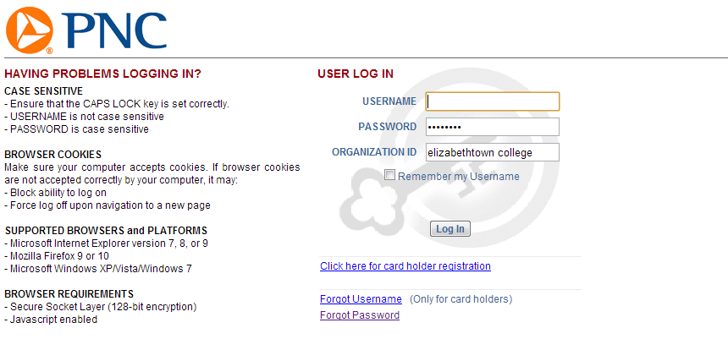To ensure receipt of notifications, add the following email address as a contact and a “safe-sender” in your   
Outlook Contacts ([activepay.notices@pncactivepay.com](mailto:activepay.notices@pncactivepay.com)).

Username:

Password:

Organization ID: Elizabethtown College

Documenting Your Transaction

Receipt RetentionCardholders are required to keep original receipts for each transaction. You will be requested to sign a sales draft for all in-person transactions. The vendor will match your signature to the signature on the back of your PCard. Please retain the sales draft and any documentation the vendor provides with your purchase.

If you are completing a transaction over the phone or via the Internet, it is important that the vendor still provide you with a sales draft and verification that the item was paid for by VISA. They will need to send this information with your merchandise. Please remind the vendor to always include a sales draft with your purchase.  
  
Missing ReceiptsPCard transactions must have support documentation. In the event the original receipt is lost, a Missing Receipt Form must be completed and submitted with the statement.

Travel, Dining & Entertainment ReceiptsEntertainment receipts and dining expense must include the purpose for the transaction. All dining receipts should include the purpose, all persons present, and the details including quantities and items ordered. Failure to provide the appropriate information could result in temporary card suspension.



People present & purpose

Miscellaneous Transactions (Gift Cards, Flowers, etc)  
The following items require detailed information including the purpose and/or event.

* Apparel, Gift and Retail Stores
* Gift Certificates
* Flowers

Reconciling Receipts & Your Statement

Once you have completed your review of the statement, initial your statement, attach all receipts and supporting documentation to the statement and turn it into your supervisor for approval. Your supervisor will review your statement, sign their approval, and then send the documentation to the Purchasing Office for audit and storage. Statements will be sent back to the cardholder if transactions are missing back up support and/or the details of the T&E (travel and entertainment) expenses are not identified.

If an external audit is conducted, cardholders must be able to produce receipts or proof the transaction occurred. If an error is found, the cardholder is responsible to show the error or dispute process has been invoked.

* Hardcopy statements will not be mailed to the cardholder.
* Cardholders are responsible for retrieving statements from the ActivePay website, see the ActivePay guide for specific instructions.
* Appropriate receipts should be attached to the proper statement for each month.
* Statements must be signed by the cardholder and the cardholder’s approved auditor.
* Statements are sent to the Purchasing Office for the statement audit.
* Incomplete statements will be sent back to the cardholder for more information.
* Statements more than a month behind are subject to temporary card suspension.

Approval Signatures

The cardholder and their supervisor must sign the statement as confirmation of reconciliation and approval.



Cardholder Approval

*BJL* Susan Mannington

Approver Signature

Statement errors

Unauthorized Transactions

If you do not recognize a transaction or a group of transactions, you should contact the Program Administrator immediately to begin the dispute process. Your card number may have been compromised and your account may need to be closed.

The dollar amount that appears on your Statement is incorrect  
Contact the vendor to find out why it is different than your sales draft. The vendor should adjust the charge to your signed sales draft. If they are going to issue a credit, make sure you get a copy of the credit slip. If you are unable resolve the issue with the vendor, contact The Program Administrator.

Product Not Received

If a product hasn’t been received and it appears on your statement, the vendor may not have sent it yet. The item may also have been lost during shipment. Contact the vendor immediately and find out when and where your shipment was sent. If you are unable to resolve the issue with the vendor contact The Program Administrator to begin the PCard Dispute Process.

Credit not applied to your Statement  
The merchant may have not submitted the credit in time to post to your current statement. Contact the merchant and inquire about the status of your credit. If you are unable to resolve the issue with the vendor, contact the Program Administrator. It is the cardholders’ responsibility to ensure proper credits are received and to make follow up calls if necessary. If you are unable resolve the issue with the vendor, contact The Program Administrator.

If you are unable to resolve the issues described above with the merchant, contact the Program Administrator to begin the dispute process. The cardholder must complete a Billing Inquiry form in order to begin the dispute process. Cardholders may be asked to supply copies of all the documentation pertaining to the unauthorized transactions.

Frequently Asked Questions

What is a Purchasing Card?  
It is a convenient timesaving tool that can be used for purchases under $1,000. It can also be used for all travel needs. Using the p-card eliminates purchase orders (under $1,000), invoices, check requests, petty cash transactions, and personal reimbursements.

Who accepts PCards?

Any supplier who accepts VISA will accept our purchasing card. The card can be used in person, by phone, fax, or online.

What are the limits on the PCard?  
Limits on p-cards are set at $1,000 per transaction. Also, there are limits based on total spending limit per cycle and the number of transactions. PCard users will be notified of specific limits.

What are the cardholders’ duties?  
All cardholders must attend training and sign a usage agreement before receiving their p-card. In addition, card users must complete an online log of their p-card purchases and reconcile it monthly. All supporting receipts and documents must be sent to the Business Office at the end of each cycle.

How should sales tax be handled?  
The College is exempt from sales tax. The sales tax exemption identification number is imprinted on the face of every p-card. In addition, a reduced size sales tax exemption certificate will be issued with every card for merchants who request to see it. However, it is the cardholder’s responsibility to make sure the College is not charged sales tax on purchases.

Will my PNC Purchasing Card show up on my credit report?  
No. This account is secured by your company’s credit and not your personal credit. The activity on this account cannot be reported to any credit bureau by PNC Bank.

Can someone else use my card to make a purchase for me?  
No. This account is in your name and must not be used by anyone else.

Can a vendor charge me a surcharge to use my card?  
No. If this occurs contact your Program Administrator they will be able to file a claim with PNC Bank.

What if my card is lost or stolen?  
Contact PNC Bank IMMEDIATELY at 1-800-685-4039 to report your card lost or stolen. Contact your Program Administrator after you have cancelled your account. A card that has been reported lost cannot be re-opened; your Program Administrator will have a new card for you in 3 business days.

What is a cycle date?  
The cycle date is when all activity for the previous month is reported to the bank for payment. Your limits will also be refreshed and you will receive your memo statement approximately 7 business days after your cycle date. The cycle ends on the 27th of the month. On the 28th, you will resume to your credit limit for the next month.

Who will be the cardholders in my department?  
Purchasing Cards can be issued to any full-time Elizabethtown College employee who will be doing college purchasing. Distribution of student employee cards is at the discretion of the Purchasing Department.

Which default accounting codes should be assigned?  
All cards are assigned a default accounting code determined by the department or person applying for the card. All charges will be charged against this account unless reallocated on the Allocation website. All college budget numbers are available from drop down menus on the site.

Will cards be held centrally or individually?  
Managers have the option of allowing cardholders to retain their cards or holding them centrally and issuing them as needed.

Who will be responsible for transaction allocation?  
The allocator is designated by the card requestor.  
  
Who will retain original receipts and reconcile the monthly statements?  
In most cases, cardholders are responsible for purchasing, tracking, allocating and reconciling. In other cases, Managers designate another individual for the above actions. It is still the responsibility of the purchaser to hand in receipts and provide documentation to the person managing the above.

Purchasing Card Agreement Form

Your participation in the Visa Purchasing Program is a convenience that carries responsibilities along with it. Although the card is issued in your name, it should be considered company property and should be used with good judgment. Your signature below verifies that you understand the Visa Purchasing Program guidelines outlined below and agree to comply with them.

1. The Visa Purchasing Card is provided to employees based on their need to purchase business-related goods and services. A card may be revoked at any time based on change of assignment or location. The card is not an entitlement nor reflective of title or position.
2. The card is for business-related purchases only; personal charges are not to be made to the card.
3. You are the only person entitled to use the card and are responsible for all charges made against the card.
4. Improper use of the card can be considered misappropriation of company funds, which may result in disciplinary action, up to, and including termination.
5. All charges are billed directly to and paid directly by the College. Any personal charges on the card could be considered misappropriation of company funds since the cardholder cannot pay the bank directly.
6. Cardholders are expected to comply with internal control procedures in order to protect company assets. This includes keeping receipts, reconciling Visa purchasing monthly statements and following proper card security measures.
7. Cardholders are responsible for reconciling their Visa Purchasing monthly statement and resolving any discrepancies by contacting the supplier.
8. Each account is assigned a cost accounting code by management and purchases may be automatically charged to that code. The code can only be changed by management approval. If changed, a new accounting code does not affect past charges, only future charges.
9. A lost or stolen card should be reported immediately by telephone to PNC Bank Customer Service at 1(800) 685-4039 and the Program Administrator.
10. A cardholder must surrender the card upon termination of employment (i.e. retirement or voluntary/involuntary termination). At this point, no further use of the account is authorized.

|  |  |
| --- | --- |
| Card Type: | Issue Date: |
| Last 4: | Cardholder Name: |
| Primary Cardholder Signature | Trainee Name/Signature |

Cc: Purchasing (Original) Human Resources (Copy) Cardholder (Electronic Copy Emailed)

PCard Missing Receipt Form

This form is to be completed and submitted with the monthly statement in lieu of the original receipt(s).  
Cardholder Name:   
  
Department:   
  
Card Number (last 4 digits)

|  |  |  |  |  |  |
| --- | --- | --- | --- | --- | --- |
| Date | Vendor Name | Item Description | Quantity | Unit Price | Total Amt |
|  |  |  |  |  |  |
|  |  |  |  |  |  |
|  |  |  |  |  |  |
|  |  |  |  |  |  |
|  |  |  |  |  |  |
|  |  |  |  |  |  |
|  |  |  |  |  |  |
|  |  |  |  |  |  |

I certify that the amounts shown above were expended for Elizabethtown College Business purposes:

Cardholder signature: (date)

Person Responsible for Statement Review:   
(signature) (date)

**ADMINISRATIVE USE ONLY**

Purchasing Card Reimbursement Form

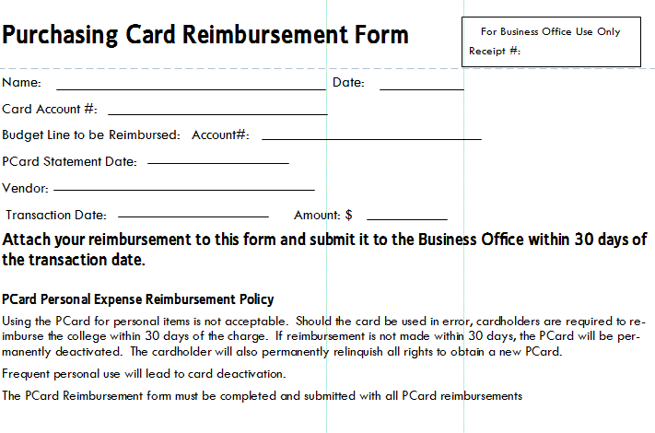

­Purchasing Card Request Form

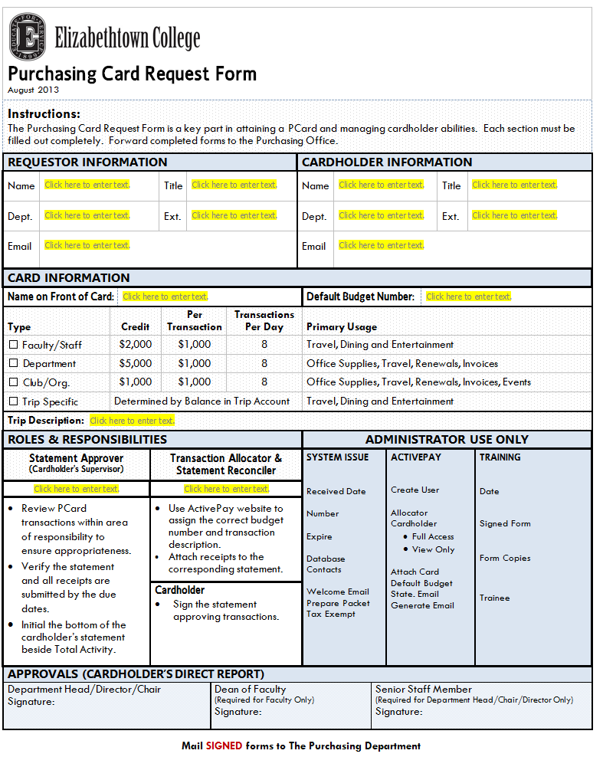

Dispute Billing Inquiry Form

