Wings of Success Co-Curricular Internship SLE Contract
Career Services Elizabethtown College
Signature Learning Experience (SLE) - Elizabethtown College is committed to engaging its students in real-world learning opportunities that complement classroom learning and provide pathways to productive careers and lives beyond college. All Elizabethtown College students will complete at least two Signature Learning Experiences (SLE) as part of their graduation requirements. This SLE is an internship affiliated with a graduation requirement.
Internship Information
Student Name:______________________________________________
Academic Major(s) & Minors(s): _________________________________________________
Name of Academic Advisor: ___________________________________

Employer/Organization Name:_____________________________________________________
Address_______________________________________________________________________
Name of Supervisor:___________________________________
Title of Supervisor:____________________________________
Telephone:________________ Email:________________________
Organization Description:
________________________________________________________________________________________________________________________________________________________________________________________________________________________________________________________________________________________________________________________

Title & description of internship position (Attach a job description if available)
________________________________________________________________________________________________________________________________________________________________________________________________________________________________________________________________________________________________________________________
Start Date:________ End Date:________ Avg. # of Hrs/Week:______________
(Internships should be a minimum of 100 hours to qualify as an SLE)
Paid/Unpaid? (Circle One)

Student Learning Outcomes
Please refer to the chart below to select four of the Top Ten Skills and Dispositions that employers seek in candidates.
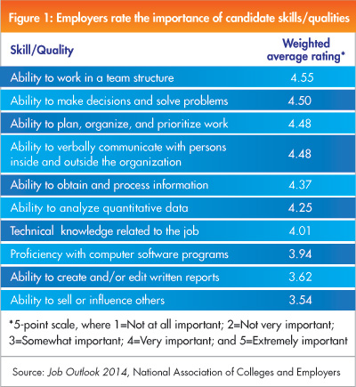
Work with your faculty advisor or the Assistant Director for Internships and Employer Engagement to write four learning objectives related to both your career goals and your academic majors and minors.
1.

2.

3.

4.

Assignments
To complete the Wings of Success Co-Curricular Internship Program, and/or to complete your Signature Learning Experience (SLE) Internship, you must do the following:
- Maintain a 5 page journal reflecting on the work you are doing, the skills and dispositions you are gaining or identifying, and your work and how you are integrating the skills you have identified.
- Keep a log of hours worked at the internship site.
- Complete two self-evaluations.
- Make certain your on-site supervisor completes two evaluations of your work and returns to the Assistant Director for Internships and Employer Engagement.
- Write a 5 page Post Internship Reflection Paper (double-spaced). The following questions may aid you, but you are not limited to these prompts. Email your paper to Tina MacKenzie (mackenziet@etown.edu) within one week of your end date.
  - Think critically about your four learning objectives for the internship. Were your learning objectives met? Why or why not?
  - What part of your internship was the most rewarding and how does this influence your decisions regarding your future and job/career choice?
  - What part of your internship was the least rewarding and how will this influence your decisions regarding your future and job/career choice?
  - Discuss how the internship confirmed or stimulated new thinking about your educational and or career direction.
  - What next steps will you take in your career development or what aspirations do you have for the future?
  - Based on the internship experience describe two or more kinds of work or tasks that you would want or not want to pursue in the future.
  - Have you learned about new jobs, careers or career paths as a result of your internship? As a result, how has your internship helped define and/or clarify your career goals/career path?
  - Think about the employees and leadership in your environment. (Based on what you have seen and experienced, how will this shape the type of employee or leader that you strive to be?)
  - What was your greatest accomplishment or reward? Or, what contribution during your internship fulfills you the most?
  - How have you grown from this experience? What was the most important thing you learned about yourself?
  - Comment on any team interaction you had. (What was your role on the team? What did you learn from interacting with others as part of a team?)
  - What has been your biggest lesson learned during your internship? Were there any surprises during your internship?
  - What has been the biggest challenge you encountered at your internship? Were you pushed outside of your comfort zone, and how did you handle the challenge?
  - Overall was your internship a worthwhile experience? Please explain why/why not. Based on your internship, are you looking forward to the future?

Required Signatures

Student Signature: __________________________ Date: ________________

Employer Signature: ________________________ Date: _________________

Academic Advisor: ________________________ Date: _________________

Assistant Director, Internships: _____________________ Date: _________________

