PA Criminal Background Check https://epatch.state.pa.us/

As of July 2015, volunteers can obtain their PA Criminal Background check and PA Childline Clearance for free. These clearances cannot be used to satisfy requirements for employment or education student field placements.

1. Click New Record Check ( Volunteers only ) 2. Read, check the box, and click accept

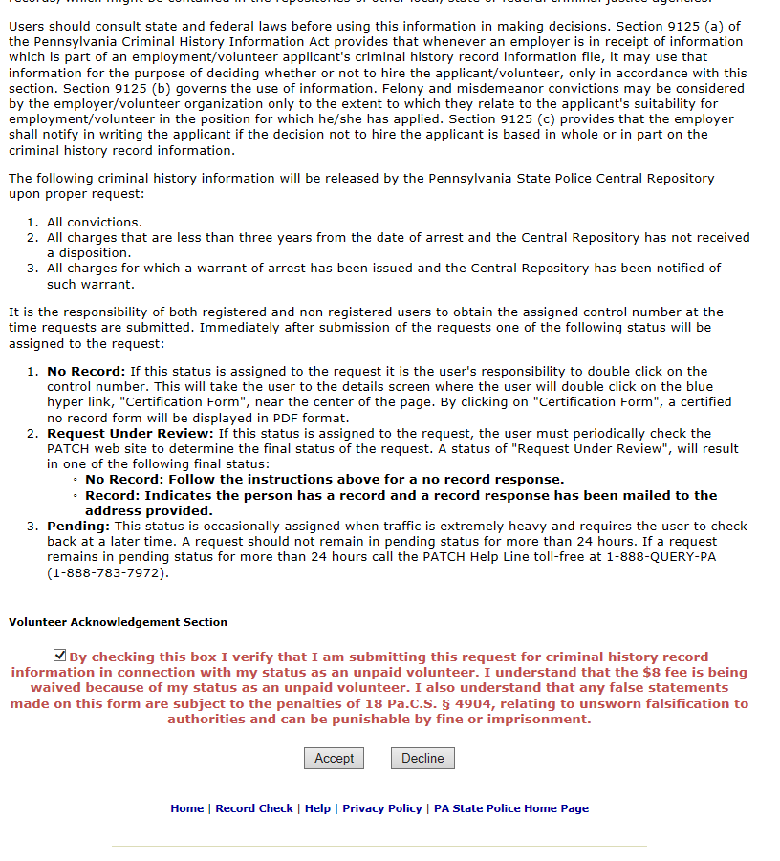

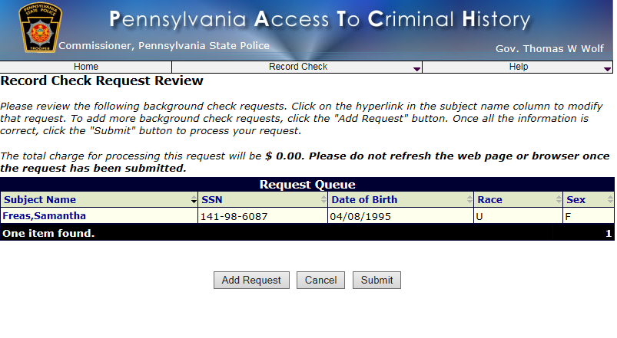

- Fill in require information 4. Fill in required information

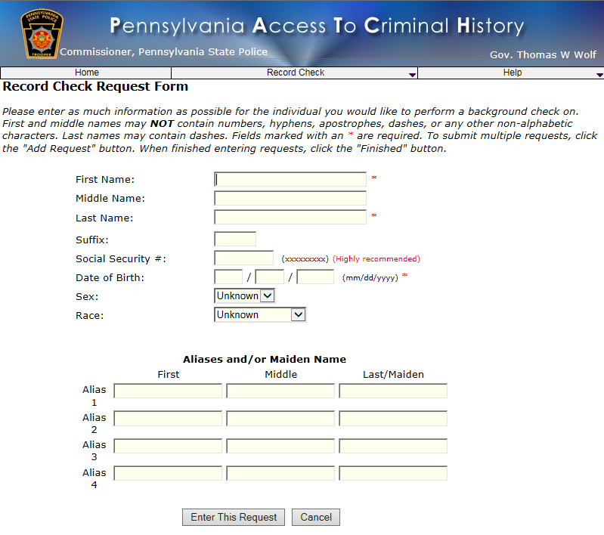
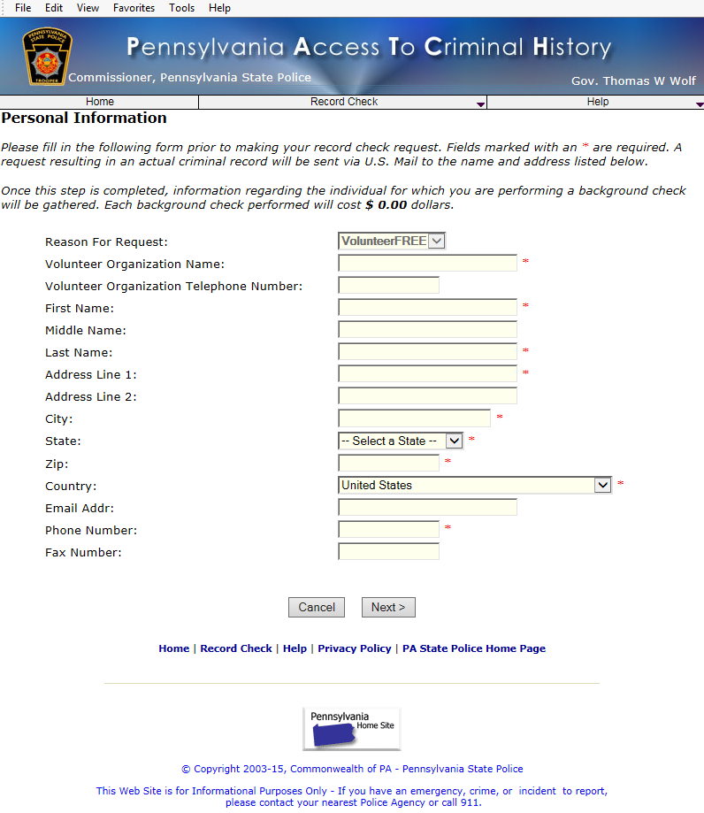

Click Finished

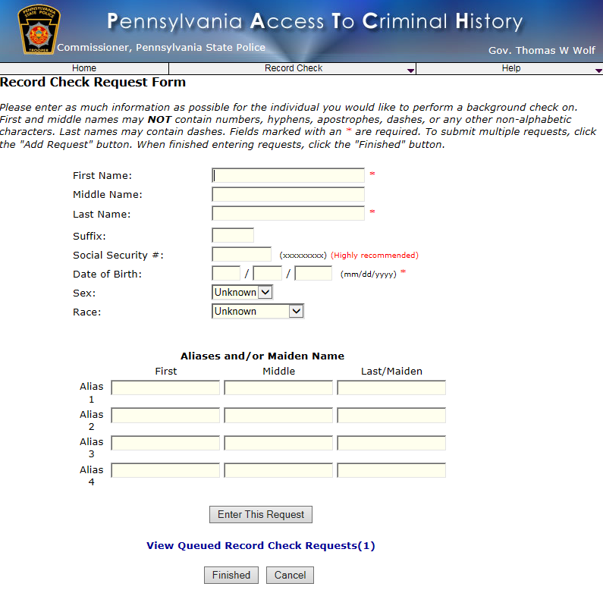

Keep a record of your Control # and the date you made the request,
if you would need to print another copy of the PA clearance.
Click on the Control number.

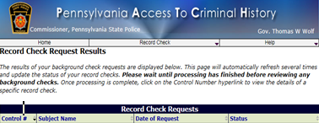

Click on Certification Form to print your PA Criminal Background Check. Keep a copy and give a copy to the CCC