FBI Clearances:
https://uenroll.identogo.com/
If you are volunteering and have been a PA resident for the last ten consecutive years, please ask your site if they will accept the Disclosure Statement Application for Volunteers (Affidavit) in place of fingerprinting. This would eliminate the need to obtain an FBI clearance at this time.
The agency you are volunteering with will determine which code you need to get your FBI clearance through. Ask the volunteer agency for their FBI clearance registration code BEFORE you proceed, because the clearance results ARE NOT always interchangeable among sites. Your site will give you a code matching their specific area within the Department of Human Services OR the Department of Education. We have found that the two most commonly used service codes are the DHS Volunteer Service Code (1KG6ZJ) or The Department of Education Colleges/Universities Teacher Education Program (1KG6RT).
Here are the possible codes for the Department of Human Services:
Service Code | Applicant Type
1KG6ZJ | DHS Volunteer
1KG71B | Foster Parent
1KG72V | Prospective Adoptive Parent
1KG738 | Child Care Services/Program Employee or Contractor
1KG74S | Family Child Care Home Provider
1KG756 | Employee >=14 Years Contact w/ Children
1KG76Q | Individual >=18 Years in Foster Home
1KG774 | Individual >=18 Years in Prospective Adoptive Home
1KG78K | Individual >=18 Years in Licensed Child Care Home
1KG8TG | Individual >=18 Years in Family Living, Community, or Host Home

Here are the possible codes for the Department of Education:
Service Code | Applicant Type
1KG6NX | Area Vocations Technical Schools (AVTS)
1KG6Q9 | Charter Schools
1KG6RT | Colleges/Universities Teacher Education Program
1KG6S7 | Intermediate Units (IU)
1KG6TR | Non-Public Schools
1KG6V5 | Private Schools
1KG6Y3 | PDE Volunteer
1KG6XN | School Districts

The cost of this clearance varies depending on which code you get, ranging from approximately $22-$28.

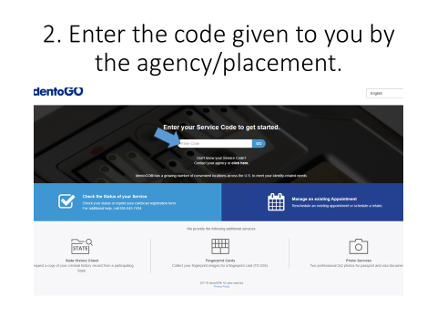
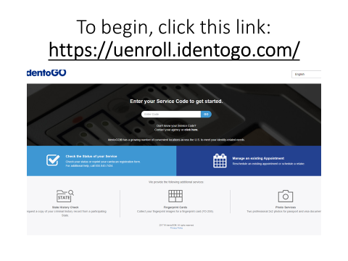
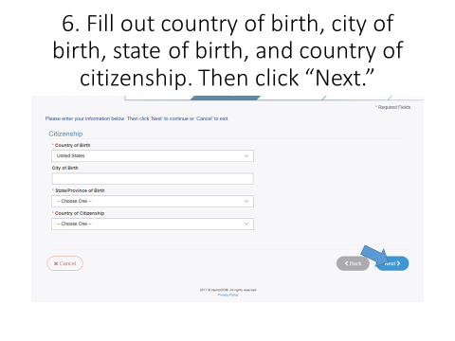
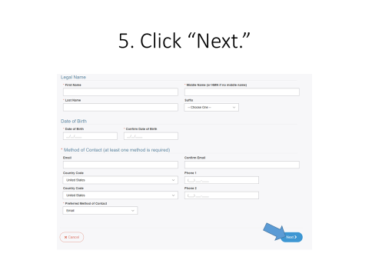
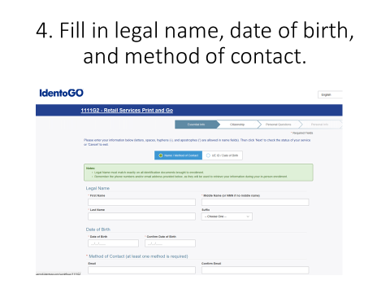
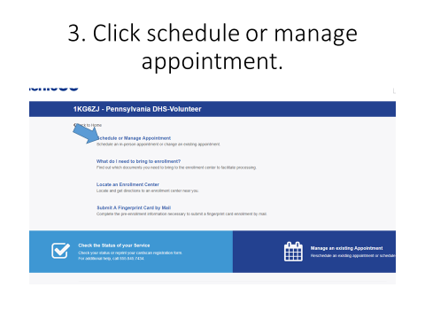

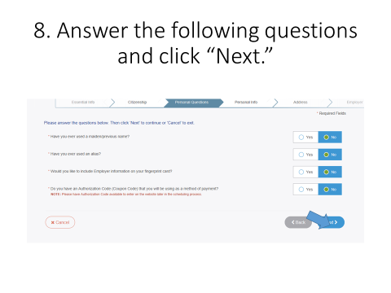
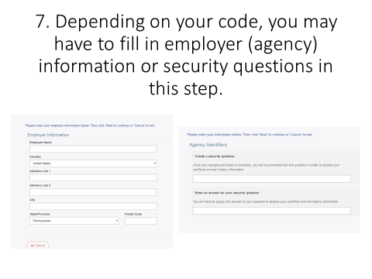
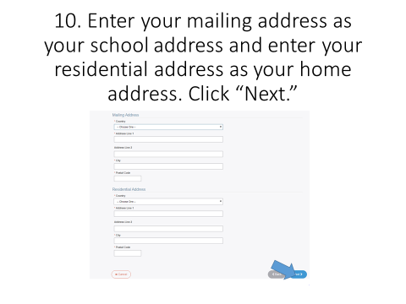
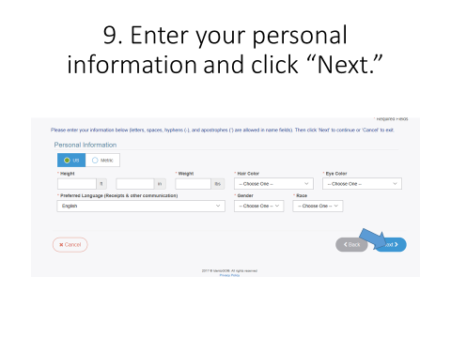
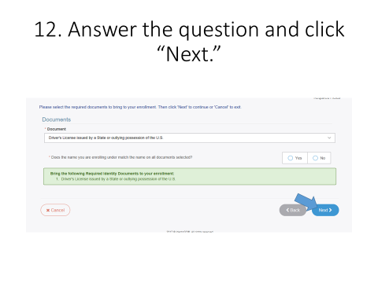
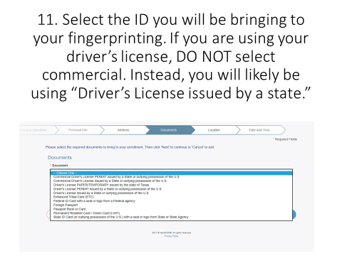

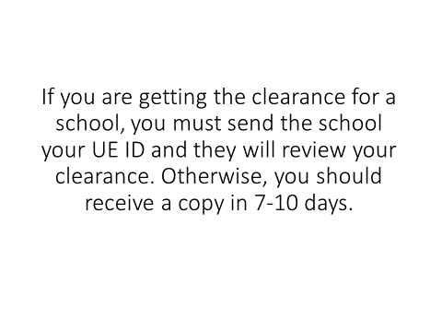
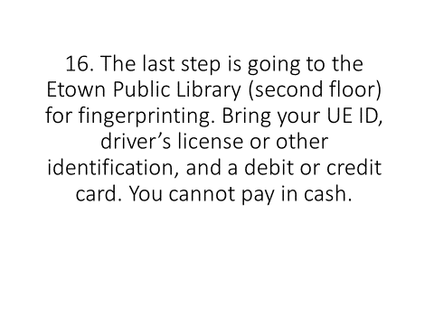
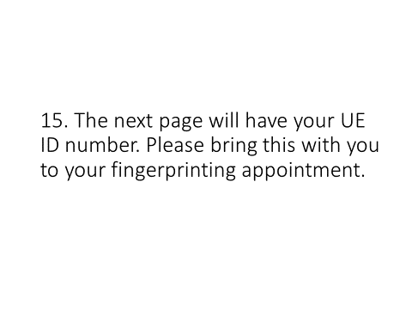
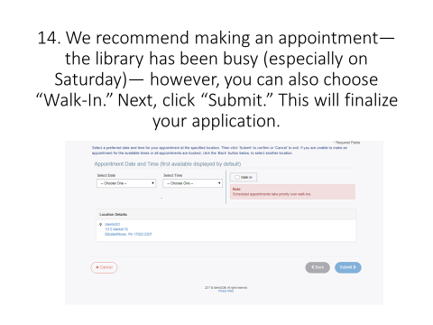
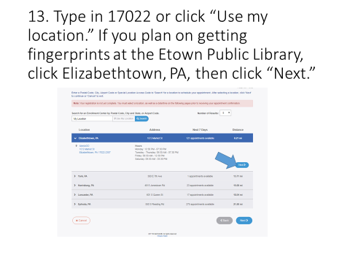

If you have any questions, please contact us at civicengagement@etown.edu or visit us in BSC258A!

