PA Criminal Background Check https://epatch.state.pa.us/

As of July 2015, volunteers can obtain their PA Criminal Background check free of charge. These clearances cannot be used to satisfy requirements for employment or education student field placements. If you’re unsure if you need a volunteer clearance or a paid clearance, please ask your agency. Directly below are directions for volunteer clearances, followed by directions for non-volunteer clearances.

1. Click New Record Check (Volunteers only) 2. Read, check the box, and click accept
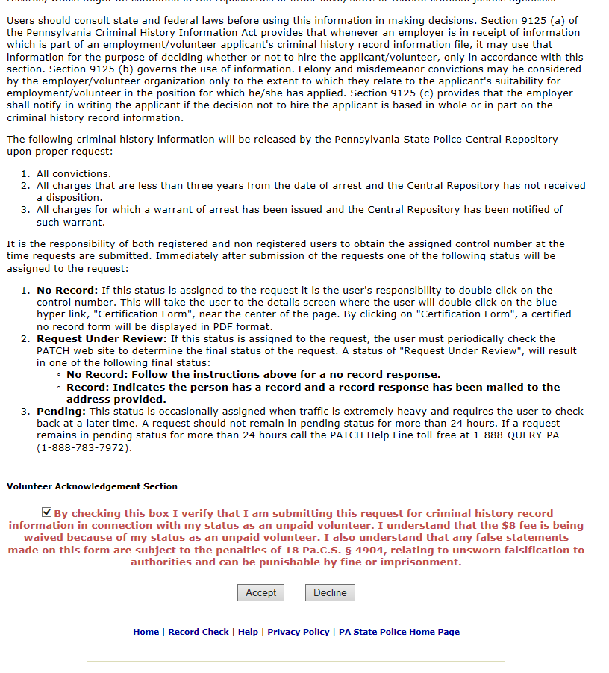

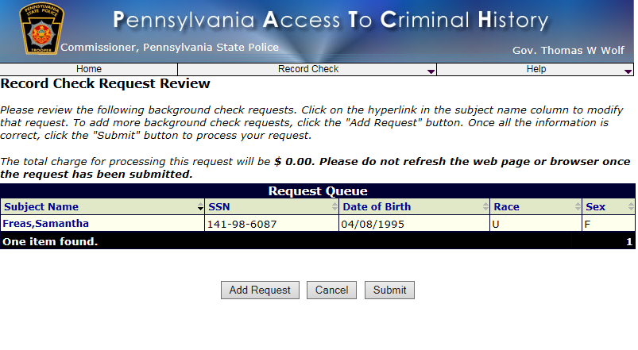

Follow the directions to complete the remaining information, until you click Finish.
Keep a record of your Control # and the date you made the request,
if you would need to print another copy of the PA clearance.
Click on the Control number.

Click on Certification Form to print your PA Criminal Background Check. Keep a copy and give a copy to the CCC

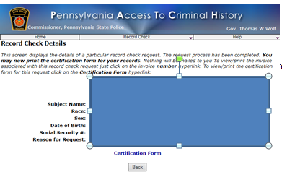
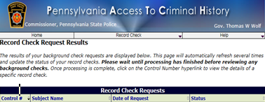

Non-Volunteer PA Criminal History Records Check: http://epatch.state.pa.us
Complete online application. Credit card required, cost $10.00 as of February 2018. Write down the control number so you can access your record if needed at a later date.
