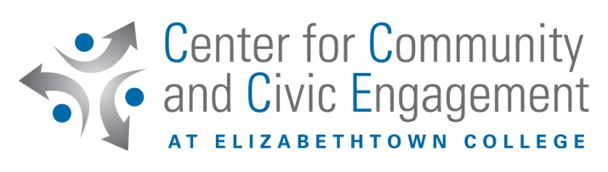

Community Service Work Study
New for the ’18-’19 school year, students must apply to participate in community service work study (CSWS) as if they were applying for student employment on campus. Instead of applying through Jayweb, students must apply through PeopleAdmin. To apply for student enrollment for CSWS, follow the steps below:

- Go to https://etown.peopleadmin.com/login; first time users must create an account. Click Create an Account at the bottom of the screen. If you try to login with your campus credentials, it will not work; you MUST create an account.
- On the left-hand side, click search jobs.
- Type Community Service Work Study in the keywords box or scroll down to find and click Community Service Work Study. This will bring you to the posting details which explain what CSWS is, if you qualify to apply, etc.
- Click the Apply for this Job button.
- First, you will be asked to fill in and complete the Personal Data section. You will only need to fill in:
  - Name
  - Phone number
  - Campus address
    - Ex. (*insert your mailbox number*) Baugher Avenue Elizabethtown, PA 17022
  - Student ID number
  - School e-mail
  - Class year
  - Home address
ONLY COMPLETE FIELDS WITH A RED * BESIDE THEM.
You do not need to fill out Availability under this section; this will be communicated directly with the agency you have chosen.
- Click the Next button.
- Filling out the Educational History section is not necessary for CSWS. Compliance to completing these sections may vary from job to job. Click the Next button. Skipping these will not prohibit your CSWS acceptance.
- Skip the Documents Needed to Apply and References sections as they are not needed to apply for CSWS. Compliance to completing these sections may vary from job to job Skipping these will not prohibit your CSWS acceptance. Click the Next button.
- The next three sections are completely voluntary and are not needed for CSWS. Skipping these will not prohibit your CSWS acceptance. Compliance to completing these sections may vary from job to job. Click the Next button after the following sections:
  - Voluntary Demographic Information
  - Voluntary Self Identification of Disability
  - Voluntary Self Identification of Protected Veteran Status
  - Click Certify and Submit to continue
- The final section asks you to Certify the information you filled in was true.
  - Read then click the box beside I certify that I have read and agree with these terms.
  - Type your initials in the box provided to verify your identity.
  - Click certify to continue
After you complete these steps, you will get the message you have successfully submitted your application. You do not need your confirmation code. You will then get an email thanking you for your interest in work study.
After the application:
- Your application will be reviewed which will confirm if you have work study in your financial aid package.
- The appropriate parties will contact you to give you the green light to start at your work study placement.
- For CSWS first-time users:
  - You will need to stop by BSC 258A or BSC 250 to determine desired placement.
- For returning CSWS users:
  - You must contact the CCCE office and your desired agency to confirm your continued placement. Please, do not start at your desired placement until you have been cleared to do so.

