Transportation Options through the Etown Jays App

- Coordinate with others on campus to carpool!
- Open the app, click the center icon (speech bubble) at the bottom of the page, then click the three bars in the left hand corner. Click ride sharing and make a post!

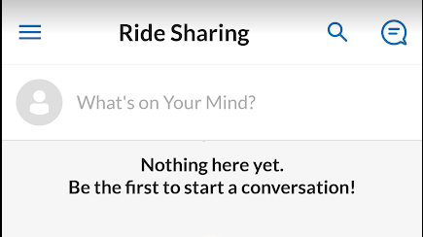

- Use the Enterprise car to get to your placement!
- Open the app, scroll down and click Student Resources, then Transportation, then Car Share to get more information.
