IB DAY

October 11, 2017

JAMES B. HOOVER CENTER FOR BUSINESS

Agenda

TIME | LOCATION | DESCRIPTION
9:00-9:30 am | Hoover 110 | Registration & Continental Breakfast
9:30-9:35 am | Hoover 110 | Welcome – President Carl Strikwerda
9:35-10:50 am | Hoover 110 | IB Advisory Board Meeting – Part 1
11:00 am-12:30 pm | KÀV | Round Table Dialogue & Lunch with Students
12:30-2:00 pm | KÀV | IB Advisory Board Meeting – Part 2

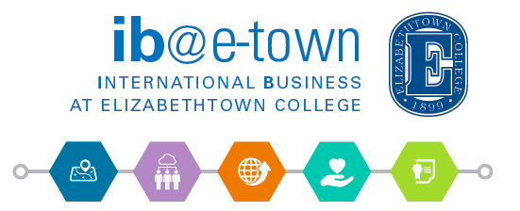
Phone: 717-361-1278
Email: ib@etown.edu

