Step by Step Guide to Completing the Work Order Request
Step A - Sign into the web site using your College User name and password. The work order page will open. 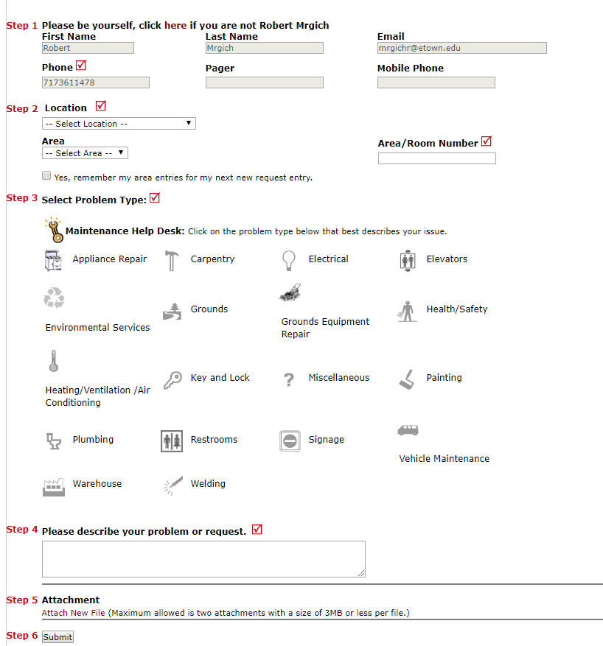
Step 1 - The form will auto populate with your information. A phone number is required.
Step 2 - Select the location of where the work is requested.
For Area/Room Number, type in the information (number or name of room).
Step 3 - Select the appropriate Type that is needed by placing your curser over the appropriate icon and left click.
Step 4 - Type in the description of the work requested. BE VERY DISCRIPTIVE with the information you send.
Be sure to include any animals in your room or special instructions for the technician.
Step 5- Attach any pictures or documents that may help the technician.
Step 6- Click on the SUBMIT icon to send the work order.
Step 7- To check the status of your Work Orders, click the “My Requests” at the top of the Work Order page.
All your Work Orders and their status will be displayed.

