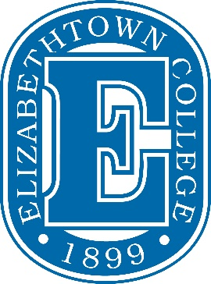

Summer 2018 Financial Aid Request Form

Student Name (print): _____________________________________

Student ID#: _____________________________________

Number of Summer Credits at Elizabethtown College:

_____ 3-Week May Session: May 14, 2018 – June 1, 2018

_____ Online Term: June 4, 2018 – August 24, 2018

_____ Graduate Students: May 14, 2018 – August 24, 2018

_____ Other (internship, practicum, etc): _____________________________________________

_____ Total # of Summer Credits

Summer housing: (please circle one) Commuter / Apartment Off-Campus / Residence hall

*You must maintain at least half-time status (6 credits or more) in order to receive Federal Direct Loan funds. Loans will not be disbursed until your final summer session begins.

_____ I want to borrow the maximum Direct Loan eligibility for the above listed Summer 2018 courses.
_____ I want to borrow $___________ through a Federal Direct Loan for the
above listed Summer 2018 courses (you must enter an amount).

_____ My parent will apply for a Parent PLUS loan and will submit an application online at www.studentloans.gov (minimum enrollment of 6-credits is required).

Signature: __________________________________________

Date: ___________________________________________

Return Form To: Financial Aid Office, Elizabethtown College, One Alpha Drive, Elizabethtown PA 17022
or through our Secure Document Upload

Contact us at (717) 361-1404 or finaid@etown.edu with any questions.

