CITI Human Subjects Research Ethics and Compliance Training

Please follow these instructions on how to complete your registration for the CITI Human Subjects Research Ethics and Compliance Training.
Once you have completed the registration, continue on to take your required courses.

Start at www.citiprogram.org

Step 1: Select Your Organization Affiliation:
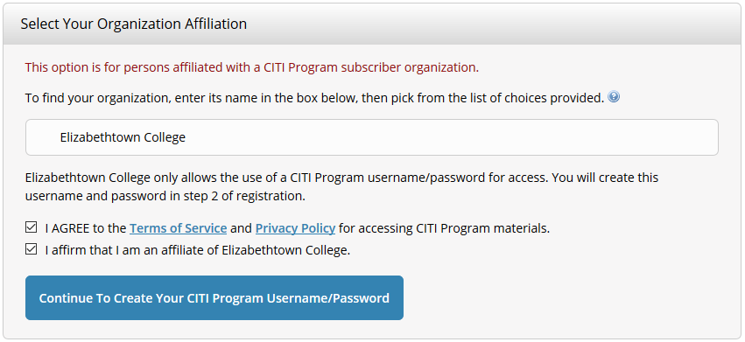
- Select Elizabethtown College as your organization.
- Check both boxes to agree to CITI’s terms of service and affirm affiliation to Elizabethtown College.
Step 2: Enter Personal Information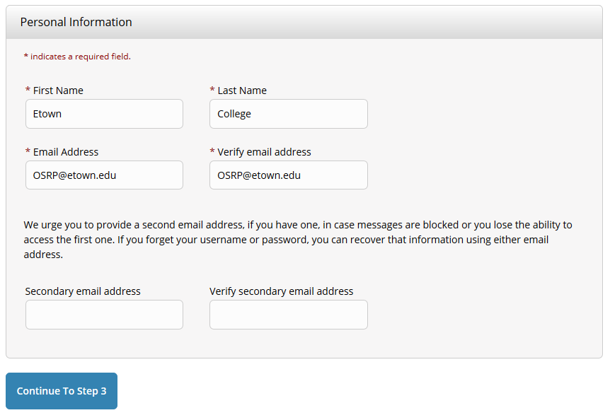

- Enter your first and last name as well as your college email address.
- Enter in a secondary email if you wish.

Step 3: Create your username and password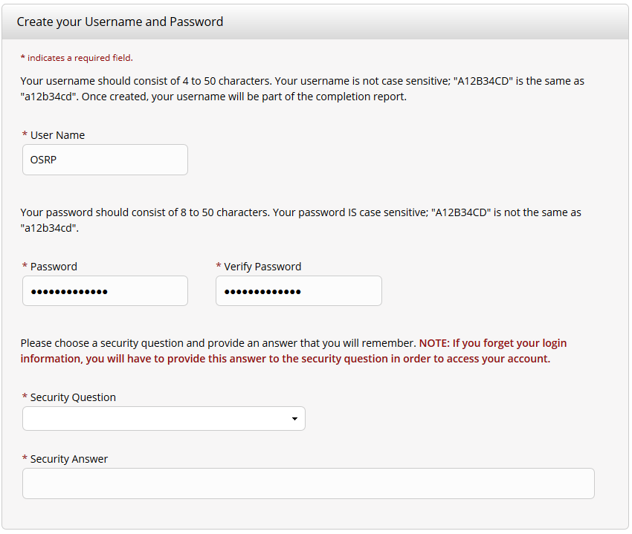
- Create your username and password.
- Fill out a security question and answer. Take note to remember your username, password, and security answer.
Step 4: Country of Residence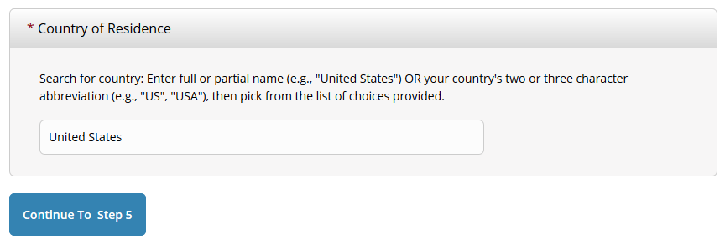
- Fill out the form box for your current country of residence.

Step 5: Optional Credit for Courses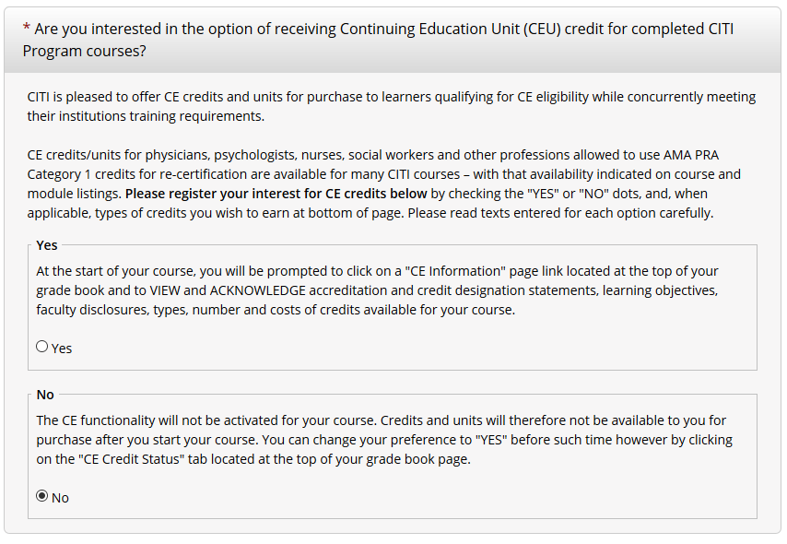
- Select the “No” option UNLESS required by your professor. If “Yes”, then select which credit you would like to earn.
- Select “No” for the next two questions.

Step 6: Fill out Personal Information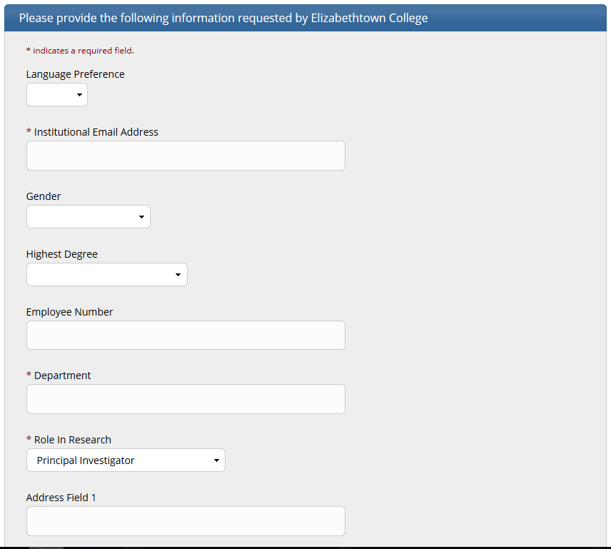
- Fill out forms with your institutional information
- Professors fill out role in research as “Principal Investigator”
- Students fill out role in research as “Student Researcher – Undergraduate”

Step 7: Select Curriculum
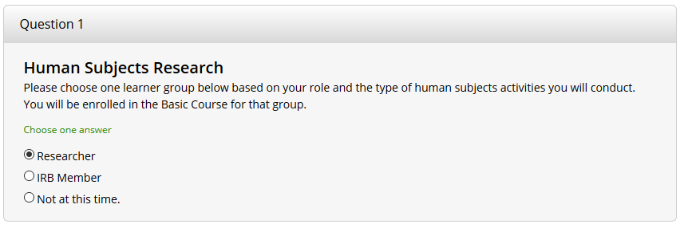
- Select Researcher
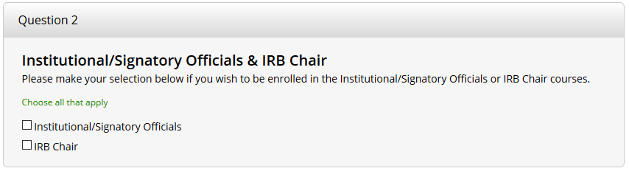
- Leave this section blank
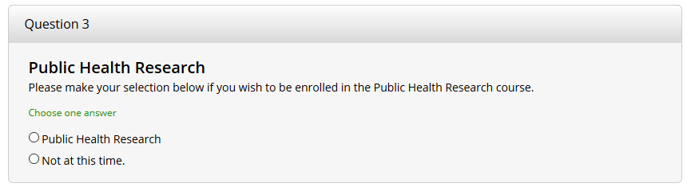
- Select not at this time UNLESS required by your professor to complete the Public Health Research course.
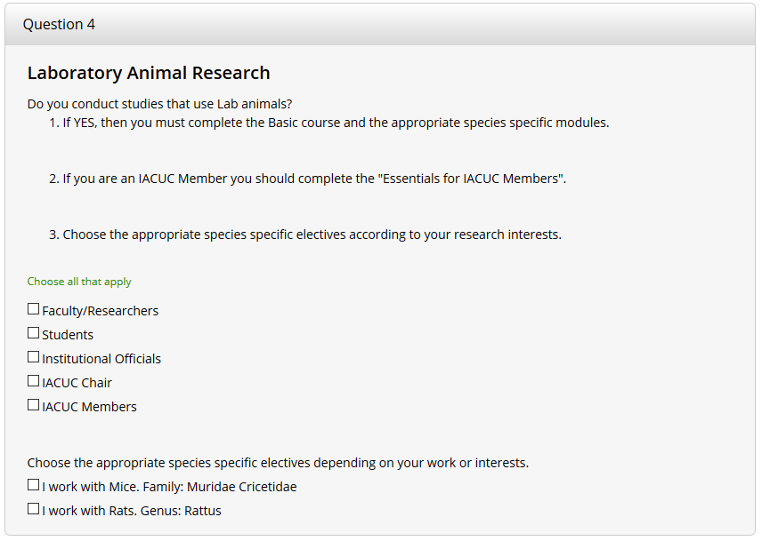
- Leave this section blank UNLESS required by professor or working with animals.
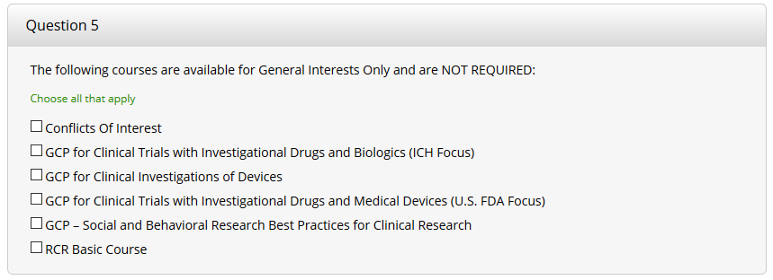
- Leave all blank. All are optional courses for additional training.

Step 8: Complete Registration
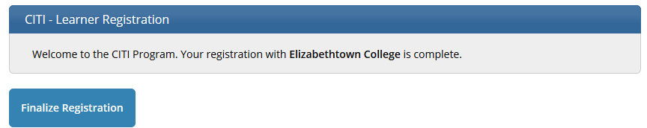
- Congratulations! You have completed your registration for the CITI program for your IRB requirement.
- Click finalize registration and begin your courses.

