IRBnet.org New User Registration

Please follow these instructions on how to complete your registration for IRBnet.org and begin your new project.

Start at www.IRBnet.org

Step 1: New User Registration:
- Select New User Registration.
Step 2: Create your username and password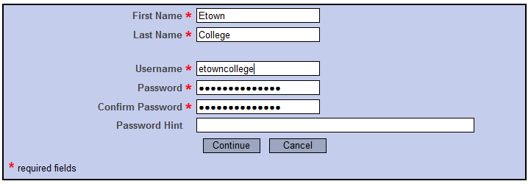

- Enter your first and last name.
- Create a username and password.
- Enter in a password hint if you wish.
Step 3: Accept terms of use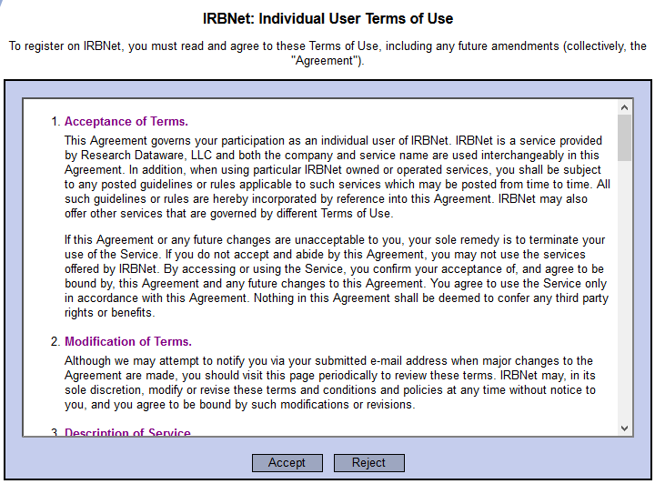
- Read through the IRBNet: Individual User Terms of use.
- Click “Accept”.
Step 4: Add your institutional affiliation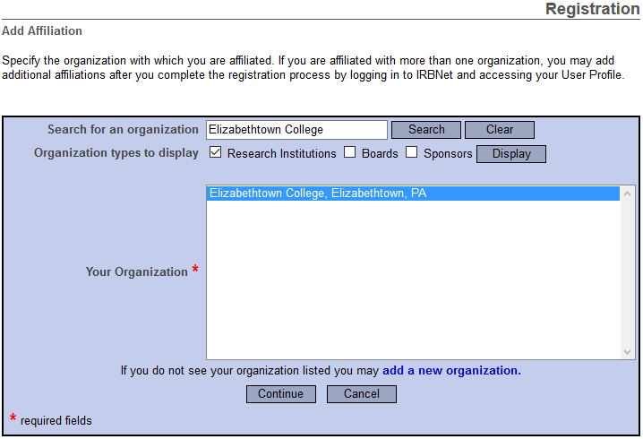
- Search for Elizabethtown College in the form box and select it in “Your Organization”.

Step 5: Enter personal information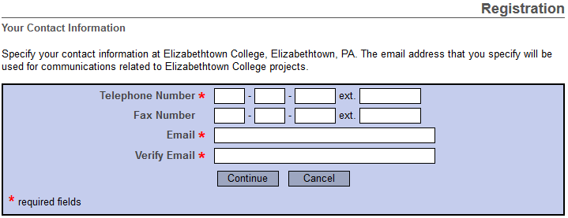
- Enter your personal information including your institutional email.
Step 6: Confirm registration information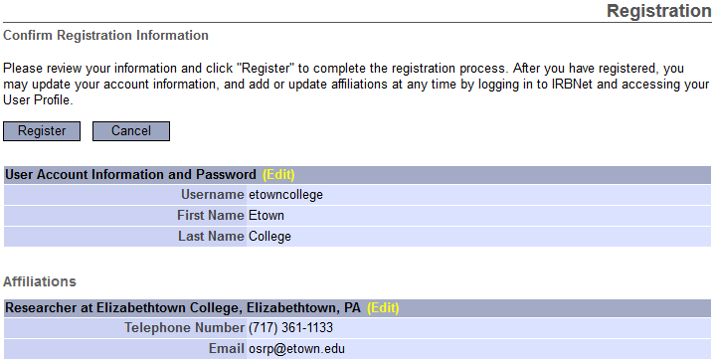
- Read through your information to insure it is correct and click “Register”.
Step 7: Activate your account
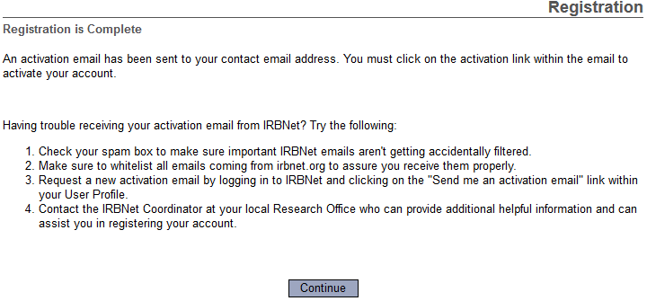
- Select “Continue”.
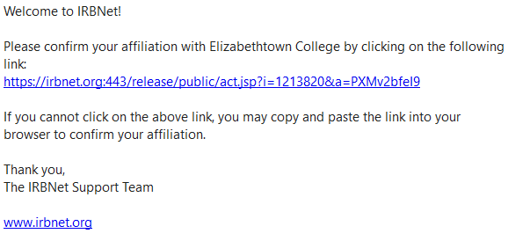
- Go to the email you provided and click the link to confirm your affiliation to Elizabethtown College.
- Congratulations! You have completed your registration for IRBNet.
Step 8: Begin your project
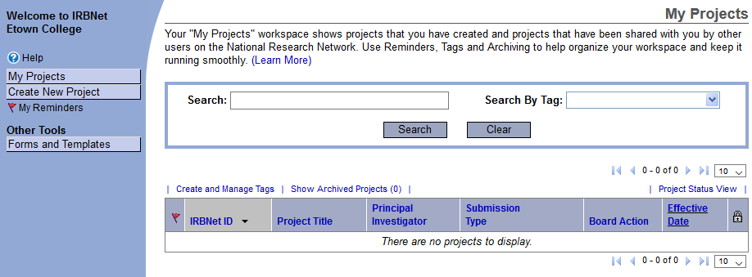
- Once you have activated your account, go back to IRBnet.org and login. On the left-hand side of the page click “Create New Project”. 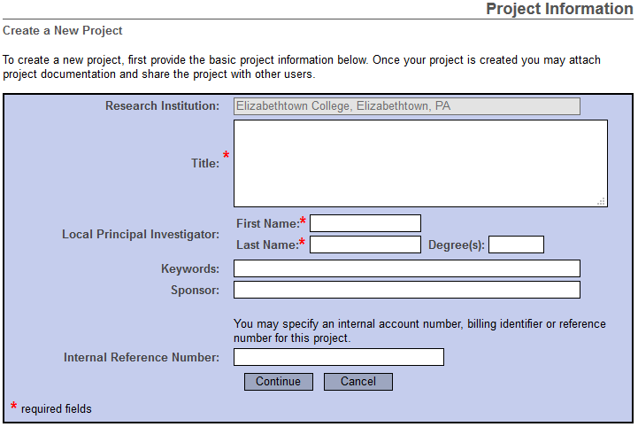
- Fill out the information for your project.
- The Internal Reference Number is optional.
- The creation of your project is now complete!

