Contents
A Practical Handbook for Supporting Community-Based Research with Undergraduate Students (2 copies) 1
Advancing Undergraduate Research: Marketing, Communications, and Fundraising (2 copies) 2
Creative Inquiry in the Arts & Humanities: Models of Undergraduate Research (2 copies) 3
Faculty Support and Undergraduate Research: Innovations in Faculty Role Definition, Workload, and Reward 4
How to Develop and Administer Institutional Undergraduate Research Programs 5
How to Get Started in Arts and Humanities Research with Undergraduates 5
Undergraduate Research Offices & Programs: Models & Practices 6

A Practical Handbook for Supporting Community-Based Research with Undergraduate Students (2 copies)
Authored by Deanna Cooke and Trisha Thorme

Table of Contents

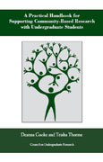
A Practical Handbook for Supporting Community-Based Research with Undergraduate Students will help colleges and universities initiate and support community-based research (CBR). This volume addresses the special rewards and challenges in connecting undergraduate students with change oriented community-based projects and provides a roadmap for implementing CBR with undergraduates. It lays out a process for conducting CBR with students, dealing with issues such as developing and maintaining partnerships, developing research questions, collecting and analyzing data, and reporting findings. Guiding questions and practical tips are featured throughout. The final section describes how to develop and put in place the human and financial resources needed to implement CBR across the campus.

Advancing Undergraduate Research: Marketing, Communications, and Fundraising (2 copies)
Authored by Joyce Kinkead, Utah State University

Table of Contents

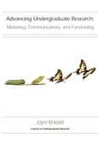
Advancing Undergraduate Research is designed to share successful models and strategies for promoting and funding undergraduate research programs. This is the first book to address the growth and improvement of undergraduate research programs through advancement activities—marketing, communications and fundraising. As such, it is a critical addition to the library of the advancement professional, the undergraduate research director, and faculty mentors—in fact, anyone who wishes to advocate for the power of research in an undergraduate’s education.

Marketing, communications, and fundraising, referred to collectively as strategic communications are all tools that help deliver the message to campus constituents, as well as to external audiences such as institutional donors, private foundations, government agencies, and state and federal legislators—that undergraduate research is a high-impact educational practice that can transform students’ lives.

Each of the three sections of Advancing Undergraduate Research focuses on key principles of advancement philosophy: how to market undergraduate research; how to engage in strategic communications; and how to raise funds and also serve as stewards of those funds for donors. Examples of best practices are included, gleaned from dozens of institutions, to illuminate the concepts and principles introduced in the volume. Advice from savvy undergraduate research directors, as well as professionals in advancement, is incorporated to help readers formulate and customize their own advancement agendas.

Creative Inquiry in the Arts & Humanities: Models of Undergraduate Research (2 copies)
Edited by Naomi Yavneh Klos, Jenny Olin Shanahan, and Gregory Young

Table of Contents

Creative Inquiry in the Arts & Humanities: Models of Undergraduate Research aims to assist faculty and administrators of any academic discipline who are creating undergraduate research opportunities that move beyond the natural and social sciences, as well as those working to sustain well-established, multidisciplinary programs. It offers examples of successful programs, assignments, curricula, journals, and conferences that support the research, scholarship, and creative activity of students in arts and humanities disciplines. Those examples cover a diversity of students’ scholarly and creative work, including individual and collaborative writing, oral presentations, works of visual art, scholarly compilations, exhibits, musical compositions, plays, performances, public scholarship, and publications in many different forms.

Those who mentor undergraduate research in the arts and humanities know the challenges of working with student researchers in disciplines in which solitary scholarship and individual creative processes are the norm. This work simply cannot, and should not, replicate a scientific model that utilizes teams of researchers, pooled data, and calibrated methods. Student research in the arts and humanities must reflect the kinds of work that scholars do in those fields. But which skills and bases of knowledge can mentors impart to students who do not have access to archives and special collections, who do not read classical languages, or who are just beginning to learn techniques that scholars in the field have mastered? How can faculty find the time to mentor individual student researchers when they are responsible for teaching hundreds of students every semester? Is it wise for faculty to invest that time in their undergraduate students’ research when they need to publish their own work for tenure and promotion? Creative Inquiry in the Arts & Humanities: Models of Undergraduate Research is a collection of replicable examples and expert advice from scholars who are fully aware of these questions and difficulties and committed to addressing them with practical ideas and successful models.

Faculty Support and Undergraduate Research: Innovations in Faculty Role Definition, Workload, and Reward
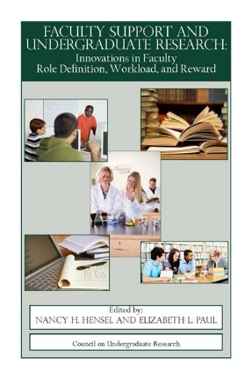
Table of Contents (pdf)

Edited by: Nancy H. Hensel and Elizabeth L. Paul
American colleges and universities, and many international institutions, are embracing undergraduate research as a powerful learning pedagogy across all disciplines and all types of institutions. Faculty and administrators have firsthand experience in observing the transformative power of undergraduate research. Though many professors consider undergraduate research as a central part of their faculty role, finding time to work with undergraduate researchers is a major concern. Even with administrative commitment to undergraduate research, institutions find it challenging to fund reassigned time for faculty or provide courses that support undergraduate research. And there is often significant controversy about whether and how faculty engagement in undergraduate research should be rewarded in reappointment, promotion, and tenure decisions. The authors in this book discuss many aspects of providing support for faculty who involve undergraduates in research. It is the editors’ hope that this book will provide inspiration and encouragement to administrators and faculty to design solutions to these challenges that can be integrated into campus practices and cultures.
"These thoughtful essays, by faculty members and administrators who have had extensive experience in the use of undergraduate research, address in practical ways the benefits and challenges of this technique for improved teaching and learning. Rather than speak only to the increasing popularity of this pedagogy, the essays address faculty members where they live—balancing concern with helping students with aspirations to carry out significant research—and provide institutions with cautionary guideposts as they work to encourage this practice. The book will be a valuable guide for both institutional newcomers in encouraging faculty/student research projects and colleges where the practice is already flourishing."
- Richard Ekman, President, Council of Independent Colleges

"There is ample evidence for the unique learning and developmental gains students realize through participation in undergraduate research and other high impact practices. The essays in this volume take the important next step of addressing the challenges inherent in integrating these practices into the curriculum, not least of which are the implications for faculty roles and responsibilities."
-Simon Gray, Program Officer, New Directions Initiative, Great Lakes Colleges Association

How to Develop and Administer Institutional Undergraduate Research Programs
- A step-by-step approach to developing and managing a campus-wide undergraduate research initiative
- Commentaries on undergraduate research issues relating to faculty, students and curricula
- Common practices and surveys
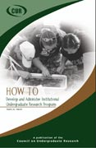
- Useful vignettes

"This manual provides a guide to the crucial questions that must be raised and answered at various stages in the decision-making and implementation process...[It is] a much needed guide for the institutions that wish to begin or expand an undergraduate research program , while at the same time it offers fresh ideas and evaluation tools for more experienced institutions."
- Larry Wilson,
Past President, Marietta College

Authored by: Toufic M. Hakim
ISBN: 0-941933-22-9
Year Published: 2000
Pages: 75

How to Get Started in Arts and Humanities Research with Undergraduates
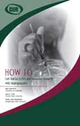
This book is designed for faculty members and administrators hoping to develop opportunities for undergraduate research, scholarship, and creative work in the arts and humanities. Since the scholarly norms, definitions of research, and roles of collaboration and individual study are distinct in the arts and humanities from those in the sciences, the book contributes new ideas for meaningful student participation in the scholarship of these disciplines and for ways in which that participation can connect effectively with faculty work. Written by faculty members with long experience working with undergraduates, the book’s eleven chapters offer models of successful practice in a wide range of disciplines and cross-disciplinary programs. Providing a practical, hands-on guide to faculty and administrators hoping to develop programs in undergraduate research in the arts and humanities, the book also argues for the broader value of making undergraduate research an integral part of teaching and learning in these disciplines.

Edited by: Iain Crawford, Sara E. Orel, Jenny Olin Shanahan
ISBN: 0-941933-52-0
Year Published: 2014
Pages: 110
Format: Print

Undergraduate Research Offices & Programs: Models & Practices
Authored by Joyce Kinkead and Linda Blockus

Table of Contents

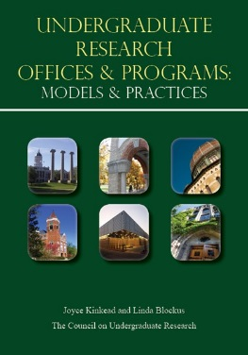
In 2000, the Council on Undergraduate Research (CUR) published How to Develop and Administer Institutional Undergraduate Research Programs, by Toufic Hakim. Although only 75 pages, Hakim’s book had a powerful influence on developing undergraduate research programs. This book has much the same aim—to provide models of undergraduate research programs that can instruct and inspire. It is the next-generation reference book and manual for those who are seeking to start or enhance existing undergraduate research programs, drawing on the wisdom and experience of more than 25 contributors. Showcasing offices and programs of undergraduate research at a variety of institutional types at various points of maturity, each of the model chapters is devoted to an institutional type and follows a template, thus making it easy for the reader to browse chapters and trace a particular theme: mission, resources, events, publications, and even challenges. The volume also offers pragmatic advice on assessment, special programs, and summer experiences. Sharing ideas and resources is a hallmark of the Council on Undergraduate Research, and it is in this spirit that Undergraduate Research Offices and Programs: Models and Practices was developed.

