To download a Student Pay Stub:

- Login to Jayweb.

- At the top of the window, choose the Student option.
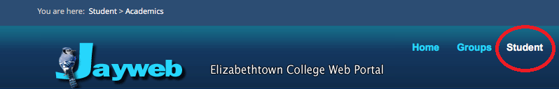

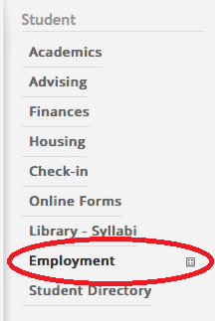
- On the left panel, choose Employment.

- In the Employment area, click on Student Direct Deposit Statement

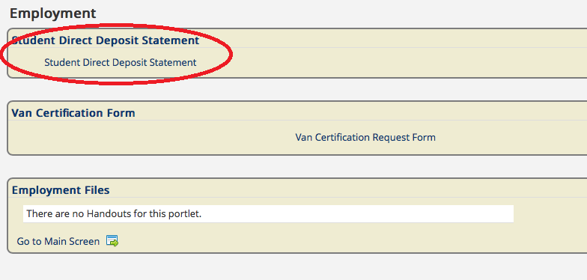

- In the Student Direct Deposit Statement - Report Parameters screen (1) select the pay date, and (2) click Generate Report

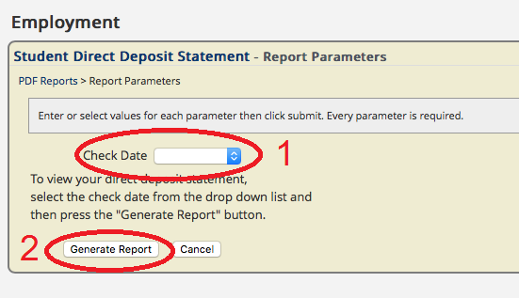

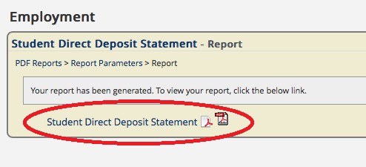
- In the Student Direct Deposit Statement – Report screen, click Student Direct Deposit Statement to generate the pdf report. Once the report is generated, you can print or save the report.

